Памятки действий в чрезвычайных ситуациях

[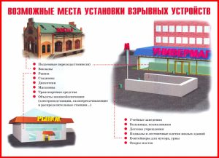](http://рябинка1.рф/wp-content/uploads/2017/03/Pamyatka-Vozmozhnye-mesta-ustanovki-vzryvnyh-ustrojstv-.jpg)[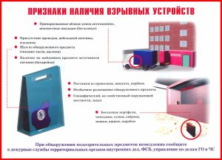](http://рябинка1.рф/wp-content/uploads/2017/03/Pamyatka-Priznaki-nalichiya-vzryvnyh-ustrojstv-.jpg)

[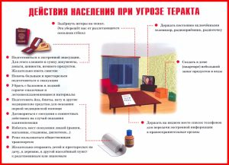](http://рябинка1.рф/wp-content/uploads/2017/03/Pamyatka-Dejstviya-pri-ugroze-terroristicheskogo-akta-.jpg)[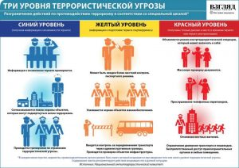](http://рябинка1.рф/wp-content/uploads/2017/03/Pamyatka-Urovni-terroristicheskoj-ugrozy-.jpg)

[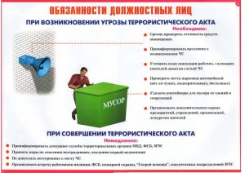](http://рябинка1.рф/wp-content/uploads/2017/03/Pamyatka-Obyazannosti-dolzhnostnyh-lits-pri-ugroze-terroristicheskogo-akta-.jpg)[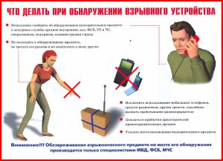](http://рябинка1.рф/wp-content/uploads/2017/03/Pamyatka-CHto-delat-pri-obnaruzhenii-vzryvnyh-ustrojstv-.jpg)

[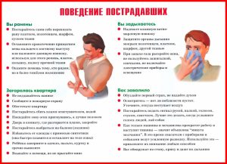](http://рябинка1.рф/wp-content/uploads/2017/03/Pamyatka-Povedenie-postradavshih-pri-terrakte-.jpg)